# HYBRID CFD-ML APPROACH TO PREDICT 3D FIN TEMPERATURE DISTRIBUTIONS USING 2D FIN MID-PLANE DATA

Soumyadeep Dey 1, Souranshu Roy Chaudhuri2, Sourav Sarkar 3, Achintya Mukhopadhyay4

1Department of Mechanical Engineering, NIT Durgapur, Paschim Bardhamman, India

2Department of Mechanical Engineering, Jadavpur University, Kolkata, India

3Department of Mechanical Engineering, Jadavpur University, Kolkata, India

4Department of Mechanical Engineering, Jadavpur University, Kolkata, India

## ABSTRACT

This study presents a machine learning approach to predict 3D fin temperatures using 2D midplane simulations, reducing computational costs. ANSYS Fluent generates 3D and 2D temperature data, from which a correction factor (ΔT = T3D - T2D) is derived. An artificial neural network (ANN) is trained to predict this correction factor, enabling efficient 3D thermal predictions without full CFD simulations. The model is validated against numerical results, demonstrating strong agreement while offering significant speedup. This method bridges the gap between simplified 2D analyses and high-fidelity 3D simulations, providing a practical tool for fin design optimization in heat transfer applications.

***Keywords:*** *Fins, Natural Convection,* *Machine Learning, CFD, Temperature Prediction, ANN*

## NOMENCLATURE

|  |  |
| --- | --- |
| *V* | Velocity field (m s-1) |
| *P*  *T*  *K*  *S*  *N*  *A*  Wi  bi  xi  yi  yi  f(.)  MSE  MAE  *Oi* | Pressure (pa)  Temperature (K)  Thermal Conductivity (W/m $⋅$ K)  Volumetric Heat Generation (W/m $​^{3}$)  Inter-Fin Spacing (m)  No. of fins (dimensionless)  Area (m2)  Weight matrix for layer i (dimensionless)  Bias vector for layer i (dimensionless)  Input value for the model (dimensionless)  Predicted temperature for the ith sample (K)  Ground truth temperature for the ith sample (K)  Activation function (dimensionless)  Mean square error (dimensionless)  Mean absolute error (dimensionless)  Output of neuron i |
| **Greek Symbols** | |
| *µ* | Dynamic Viscosity (Pa-s) |
| *∇*  *ρ* | Gradient (dimensionless)  Density (kg m-3) |
| α Thermal diffusivity (m2 s-1)  η Learning rate for Adam optimizer  δ Error term at neuron j  **Subscripts**  src Source  tgt Target  i Index for data sample or network layer | |

## INTRODUCTION

Heat transfer is quiet a essential task due to the integration of IC chips in every field. It can be physically possible by using fins. Coumputing heat transfer using 3d find ie a expensive task so we use 2d fins, but in 2d fins the results is being compromised, so we made a machine learning approach to bridge the gap between the 2d and 3d simulations.

This study focuses on enhancing heat transfer predictions for 3D extended surfaces (fins) by developing a correction factor model that bridges the gap between simplified 2D midplane simulations and full 3D thermal analyses. ANSYS Fluent simulations are employed to generate high-fidelity temperature data for both 2D and 3D fin configurations, capturing key thermal gradients and convective effects. The derived correction factor, obtained by subtracting 2D midplane results from 3D solutions, serves as the target for an artificial neural network (ANN) to enable rapid and accurate 3D thermal predictions without exhaustive computational fluid dynamics (CFD) simulations.

* 1. **Literature Review**

In their research, Sultan et. al performed a numerical analysis of a rectangular fin array attached to a horizontal heat sink to assess its natural convection heat transfer performance. Their study meticulously documented variations in temperature and velocity, alongside fluid trajectories. They also investigated how intensifying heat flow and manipulating heat flux impacted the fins' cooling efficiency. [1]

Kim et. al presented a machine learning model which predicts the heat transfer performance of a various pin-fin system. [2]

Lee et. al presented a multimodal machine learning approach that inter-relates geometric features to predict heat transfer for a given fin. [3]

For a system of 2-D fins, Karmakar et. al observed that the heat transfer first increases with the more fins and decreases with further added fins. The visualization of the temperature contour can make the reader know the behavior of the temperature distribution. [4]

## PROBLEM DESCRIPTION

**2.1 Geometry and Boundary Conditions**

This 2D and 3D analysis investigates natural convection heat transfer from an array of vertical aluminum fins mounted on a base surface. The system, enclosed in an air-filled chamber, with two fins. The base surface is maintained at 340 K, with the ambient air at 300 K. The fluid surfaces are kept as pressure outlets. The primary objective is to determine the temperature distribution at different points. For the type of flow around fins in the setup above is within Ra less than 108 that is laminar flow and the fluid properties are assumed under Bossenique’s Approximation. Fig. 1 shows the schematic of the problem.

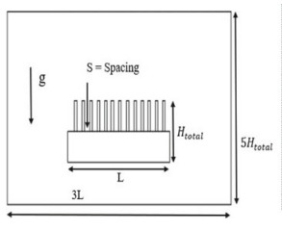

**Fig. 1 Schematic of Computational Domain**

For 3-D domain the domain was extruded by 600mm. The fluid domain was extruded 100mm extra from front and the back. The length (L) along horizontal axis is about 190 mm with fins of height (H=30 mm) installed of thickness (t=3 mm) with inter-fin spacing as (S). The fin is mounted on a base surface of thickness (tbase 30mm). The fin apparatus is made of aluminum due to higher conductivity of material. The setup is encapsulated in an enclosure of height 5H total and a width of 3L filled with air in it.

**2.2 Meshing and Grid Independence**

The default meshing techniques are used for both the 3-D and 2-D simulations and the cell size is varied to test the grid independence. Adaptive meshing is used to solve the 3-D domain.

**2.3 Numerical Modelling**

Using a finite volume technique, the governing differential equations were integrated and discretized into algebraic equations. These equations were then solved iteratively using FLUENT 19 R3's algebraic multigrid solver, with boundary conditions applied. A second-order upwind scheme was utilized for the momentum and energy equations, while the SIMPLE algorithm was used to couple the pressure and velocity terms. The convergence criteria were set to 10⁻⁶ for the energy equation and 10⁻³ for continuity and momentum. To ensure solution convergence, specific under-relaxation factors were applied for pressure, density, body force, momentum, and energy, as detailed in the Table 1.

**Table 1** **Under-relaxation factors**

|  |  |  |  |  |
| --- | --- | --- | --- | --- |
| Pressure | Density | Body Force | Momentum | Energy |
| 0.8 | 1 | 0.7 | 0.01 | 1 |

### Artificial Neural Network Model Architecture

## To predict temperature differences (∆T) at the unmeasured z-planes (z = 100 and z = 375), an artificial neural network (ANN) was trained using data from six known planes: z = 0, 175, 275, and 475 mm. Fig. 1 shows the model structure for visualisation.

* + 1. **Interpolation using IDW**

To align the (x, y) coordinates across all 2d and 3d datasets, Inverse Distance Weighting (IDW) was applied using cKDTree for efficient neighbour search. For each target point, the temperature was interpolated from its 10 nearest neighbours, with weights inversely proportional to the square of the distance (p=2p = 2p=2). This provided a consistent temperature field over the Z = 0 plane, essential for ∆T computation.

* + 1. **Temperature difference calculation**

Temperature difference (ΔT) was computed with respect to the base plane (Z = 0):

$∆T_{z}\left(x,y\right)=T_{z}\left(x,y\right)-T_{z=0}\left(x,y\right)$

This highlights the thermal variation across the z-direction and was used as the learning target for the ANN.

* + 1. **ANN model for ∆T prediction**

An ANN was trained to predict ∆T at other planes (z = 100, 375 mm) using known data from z = 0 to 475. The model used are as follows: Input: Scaled (x, y) and ∆T using Standard Scaler, Layers: 64 → 128 → 64 → 32 neurons, with Relu activation and output layer with linear activation function, Techniques: BatchNormalization is used for normalizing the data. The model was trained using the Adam optimizer with gradient clipping (clipnorm = 1.0). Loss metrics used was given in eq. 13. Early stopping improved convergence and prevented overfitting and gradual decrease of validation loss.

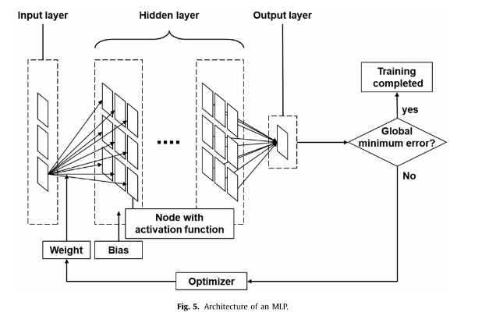

Fig 2. Structure of the ANN

Figure 2 shows the basic implementation structure of the Artificial Neural Network used along with labelled weights and biases and use of optimizer to automatically change the weights and biases to get the maximum accuracy with least error.

## EQUATIONS USED

Continuity equation for an incompressible flow is given in Eqn. 1.

$$∇⋅v=0 (1)$$

Momentum conservation in Eqn. 2 is given by-

$$ρ\left(\frac{∂v}{∂t}+v⋅∇v\right)=-∇p+μ∇^{2}v (2)$$

The conduction equation at steady state and no heat generation is given in Eqn. 3.

$$∇^{2}T=0 (3)$$

The equation at the interface is given by Eqn. 4. –

$$h_{c}*A*∆T=-k\frac{dT}{dx}=Q (4)$$

Equation 5 shows the Bossinesque approximation-

$$ρ≈ρ_{0}\left[1-β\left(T-T_{0}\right)\right] (5)$$

Equation 6 shows the fin spacing formaulation –

$$S=\frac{\left[L-\left(nt\right)\right]}{n} (6)$$

Equation 7 shows the steady-state energy equation for an incompressible fluid with constant properties and negligible heat generation :

$$V⋅∇T=α∇^{2}T (7)$$

Equation 8 shows the Euclidean distance is given by dji between jth and ith position

$d_{ji}=\sqrt{{\left(x_{j}-x_{i}\right)}^{2}+{\left(y_{j}-y_{i}\right)}^{2}}$ (8)

Equation 9 is weights for its k-nearest neighbour.

$W_ji = \frac{1}{\left(d_{ji}^{P}+ ∈\right)}$ (9)

Normalisation of the weights is given by Eqn. 10.

$\tilde{w_{j}}i=\frac{w_{j}i}{\sum_{i=1}^{k}{w_{j}}i}$ (10)

Interpolation Ti at point j is at Eqn. 11

$\hat{T_{j}}=\sum_{i=1}^{k}{w_{ji}}⋅T_{i}$ (11)

Mean absolute error formula is shown in Eqn. 12 as-

$MAE=\frac{1}{n}\sum_{i=1}^{n}{\left|y_{i}-\hat{y_{i}}\right|}$ (12)

Mean square error formula is given by Eqn. 13.

$\text{MSE}=\frac{1}{n}\sum_{i=1}^{n}{{\left(y_{i}-\hat{y_{i}}\right)}^{2}}$ (13)

Deep learning model equation is given as

$y=\sum_{i=1}^{n}{w_{i}x_{i}}+b$ (14)

ReLU activation function is given bu Eqn. 15.

ReLU(x) = max(0, x) (15)

In Peicewise Form:

$f\left(x\right)= ⎧ 0 if x ≤ 0$

$$⎩ x if x > 0$$

Equations 16 and 17 show the backpropagation to correct the weights and biases during training

$w_{\left\{ij\right\}}^{\left\{new\right\}}= w_{\left\{ij\right\}}^{\left\{old\right\}}+ η · O_{i}· δ_{j}$ (16)

$b_{j}^{\left\{new\right\}}= b_{j}^{\left\{old\right\}}+ η · δ_{j}$ (17)

## RESULTS

The resuts of the temperature contours for the 2-D and at different frontal planes across the 3-D domain have been studied. The contours for 2-D and the 3-D mid plane analysis have been shown. The results have been then compared to the predicted models.

For the 20 percent test data MAE stands as 0.0257145185 and MSE stands as 0.0032280229 and real temperature MAE is 0.3562957192.

The maximum error for Z = 100 mm plane is 12.71541 and for Z = 375 mm plane is 24.73535.

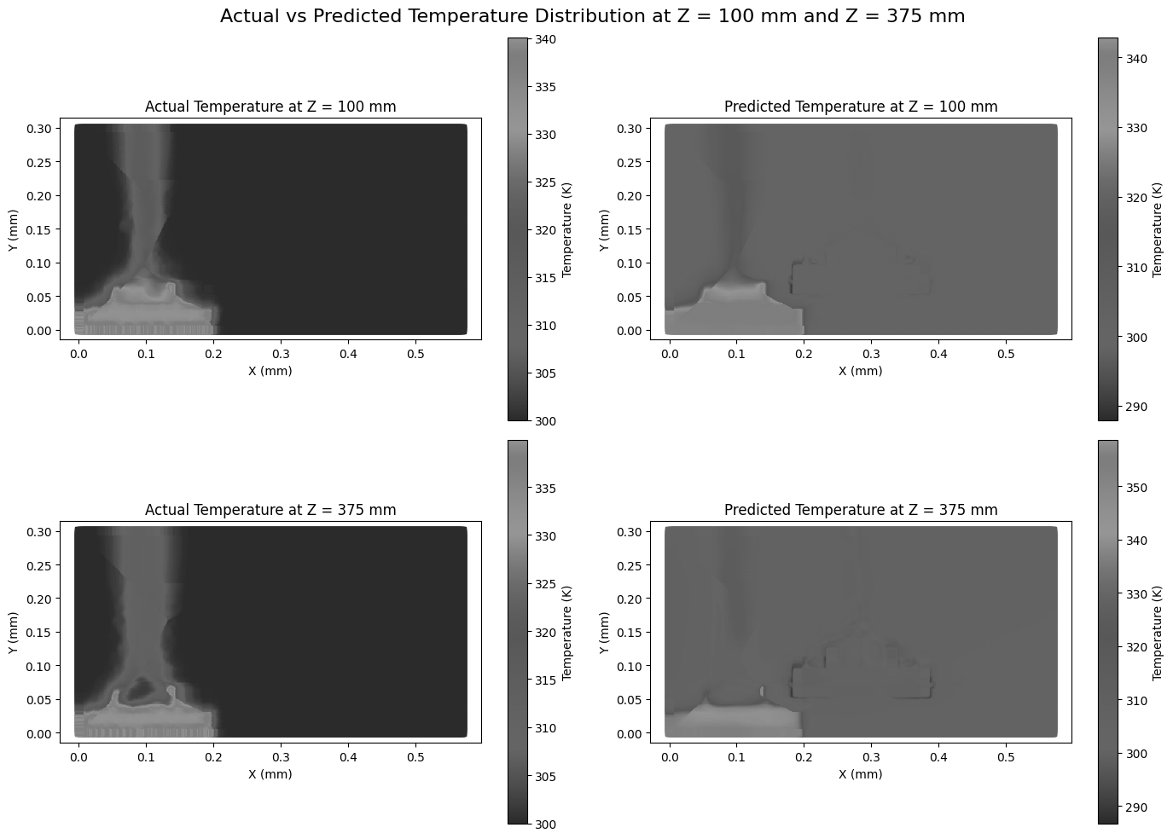

Fig 3. Actual temperature data plot of Z = 100 mm plane



Fig 4. Predicted temperature data plot of Z = 100 mm plane



Fig 5. Actual temperature data plot of Z = 375 mm plane



Fig 6. Predicted temperature data plot for Z = 375 mm plane

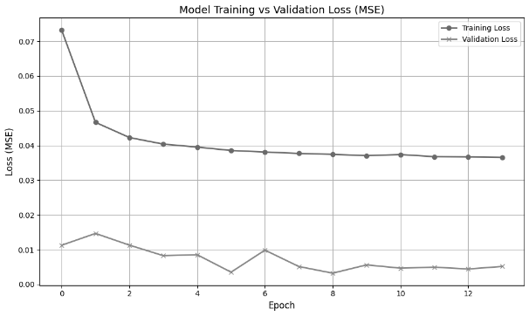

Fig 7. Plot between training loss and validation loss

## REFERENCES

*Journals*

[1] Numerical investigation of natural convection from a horizontal heat sink with an array of rectangular fins: <https://doi.org/10.1016/j.csite.2024.104877>

[2] K Kim, H Lee, M Kang, G Lee, K Jung, C R Kharangate, M Asheghi, K E Goodson, H Lee, A machine learning approach for predicting heat transfer characteristics in micro-pin fin heat sinks, 2022, 194, 123087 :

<https://doi.org/10.1016/j.ijheatmasstransfer.2022.123087>

[3] H Lee, G Lee, K Kim, D Kong, H Lee, Multimodal machine learning for predicting heat transfer characteristics in micro-pin fin heat sinks, 2024, 57, 104331:

<https://doi.org/10.1016/j.csite.2024.104331>

*Conference Papers*

[4] 2D Numerical Analysis of Natural Convection in Vertical Fins on Horizontal Base: <http://dx.doi.org/10.1007/978-981-13-1903-7_48>